**Trending Days**

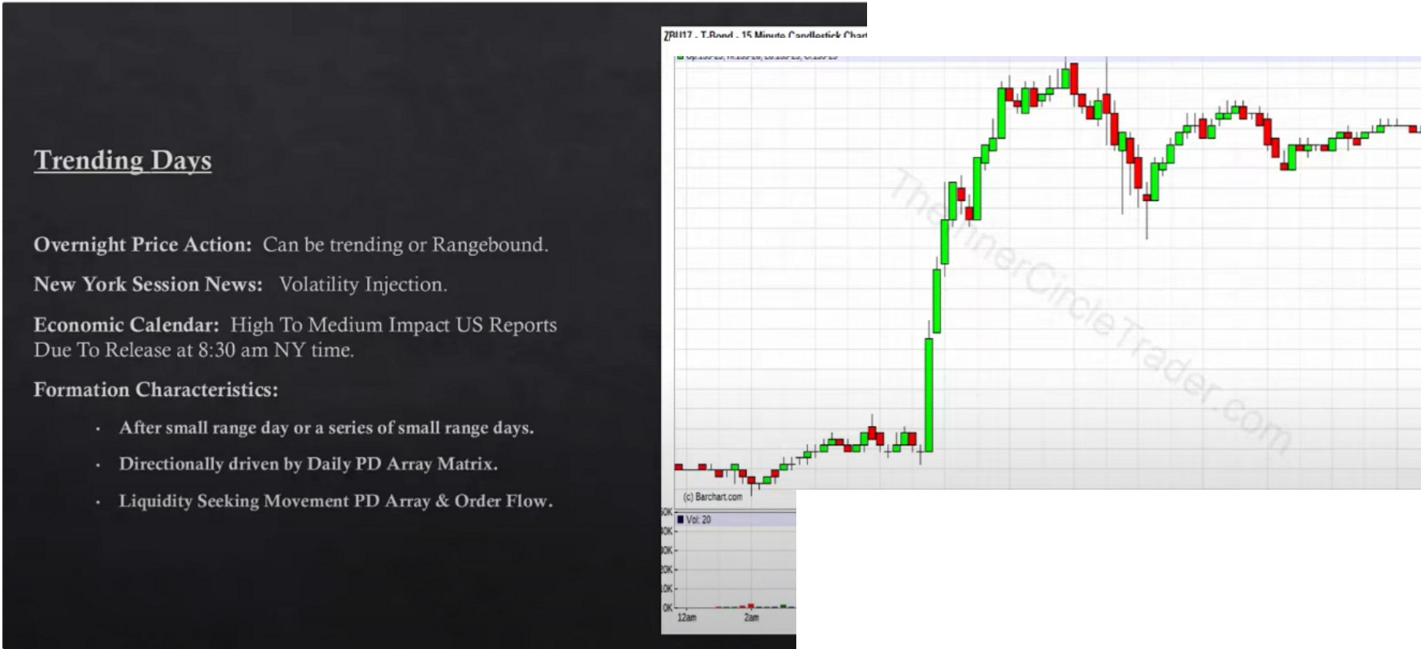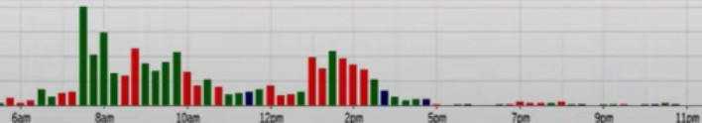

====

1"'

......

-­

***...n***

.-.-...

....

**·ISS-lt**

**-155-11**

·ll>U

--

--

--

.........

*•15'-n*

**.,,._a**

**-IS&-16**

....u

**-lS'-1**

-_-,_

......

- --==-==---===ll>n

- lllBondl,.,dmolonH

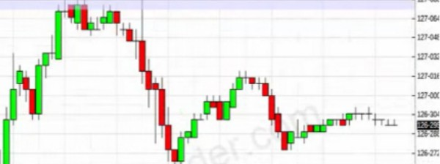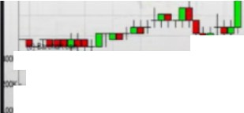

***lJllll.1 .• , ... ,.,...n....�a...***

**10..ia.a-.UW111,i..1Jt.a..cua.•**

**-IWlltl**

--.-.._-.**.: ....l11111,1!!:11.u,,::J1II ,- ..--..- .-.** ...

10 Year T Notes

TrL,1,ur\ Bond-,

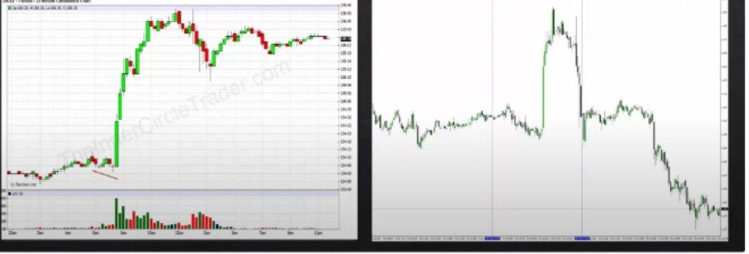

I llllhd

We can trade the morning session in FOMC but not the PM sessions

Accumulation divergence between the 30 year and 1O year, when theres banks involved we'll see displacement, it wont be a small move

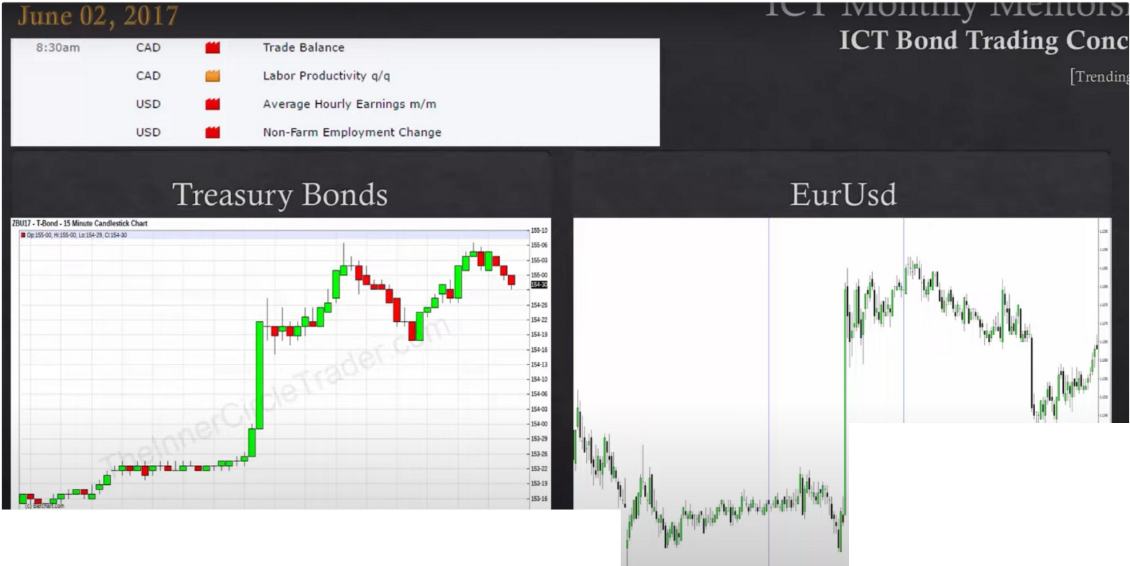

,w ....

•·- -- **------**-**c---,----,--**-**•·..**-**11.**-**....**-**l.l**■**..**-**...........**- -**....**- **•**

When youre looking for trades its important to have interest rate market sponsorship behind it Focusing on the daily, 4h and 2h will give you a good feel of what the treasury bond will likely do

When we expect an expansion and see the lows have a divergence at 8am then we know beforehand that price will be allowed to have a big expansion across all other asset classes

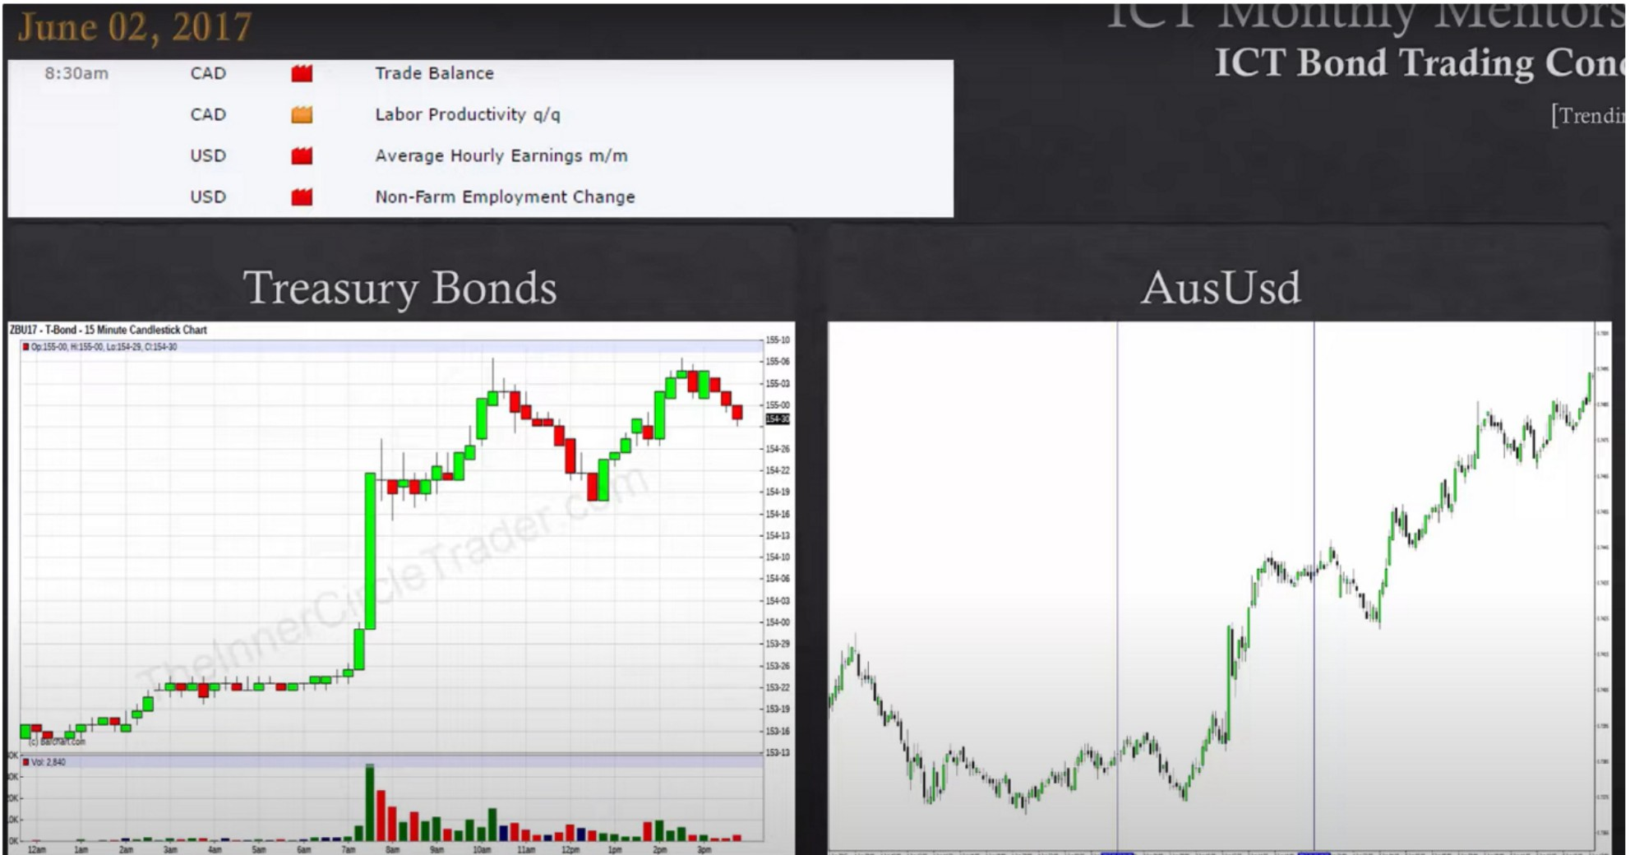

Divergence between the interest rates, the bond, 10 year and 5 year treasury

When the bond market isnt incoorporated when trading forex everyday thats low probability, we want to cherry pick our trades. Theres a common formula happening over and over

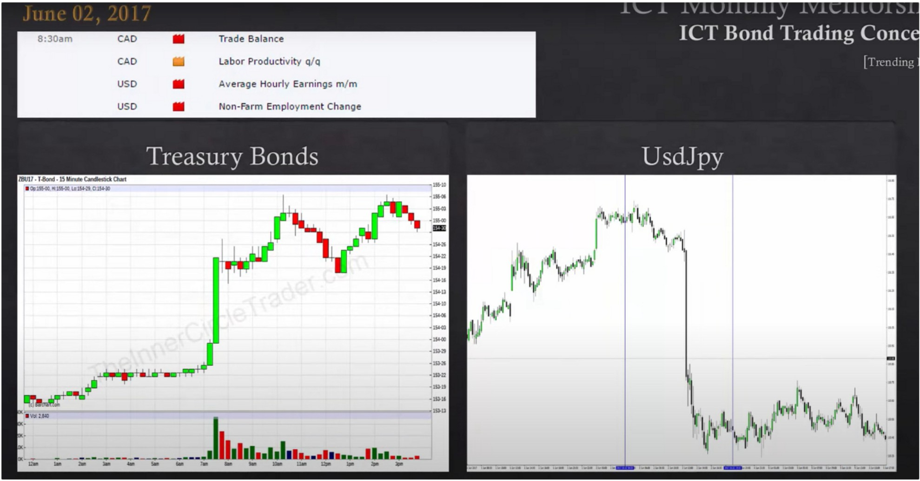

Its quick and energetic because of the bond market, the key is knowing the interest rates

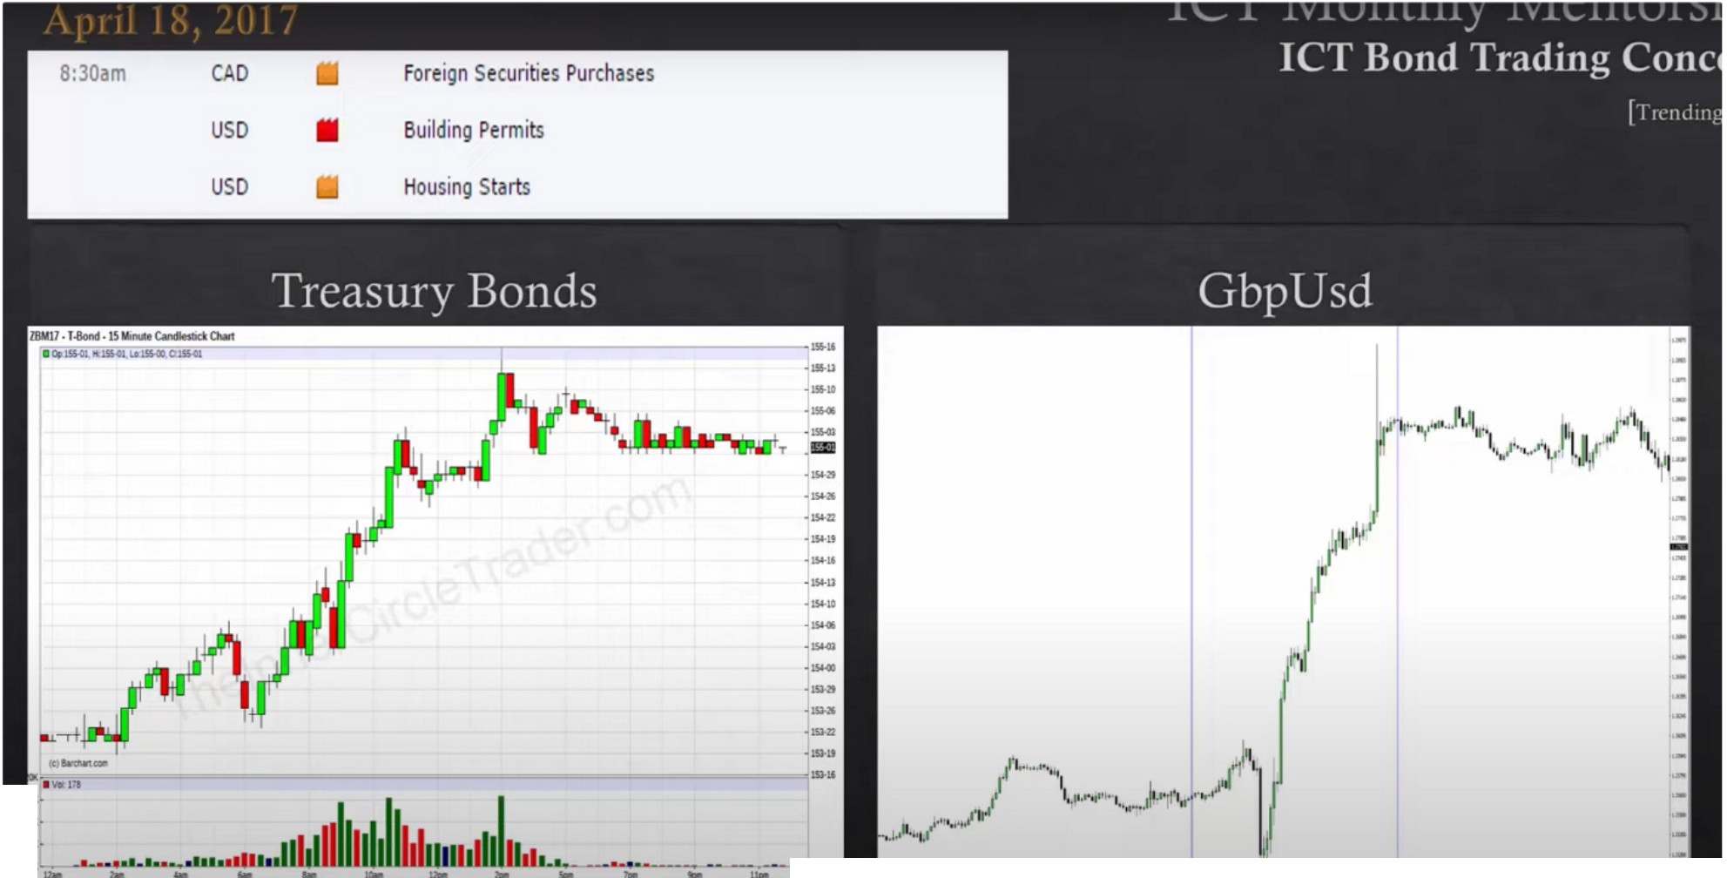

.. ··---·--·--··......_.... .....,.......... ...

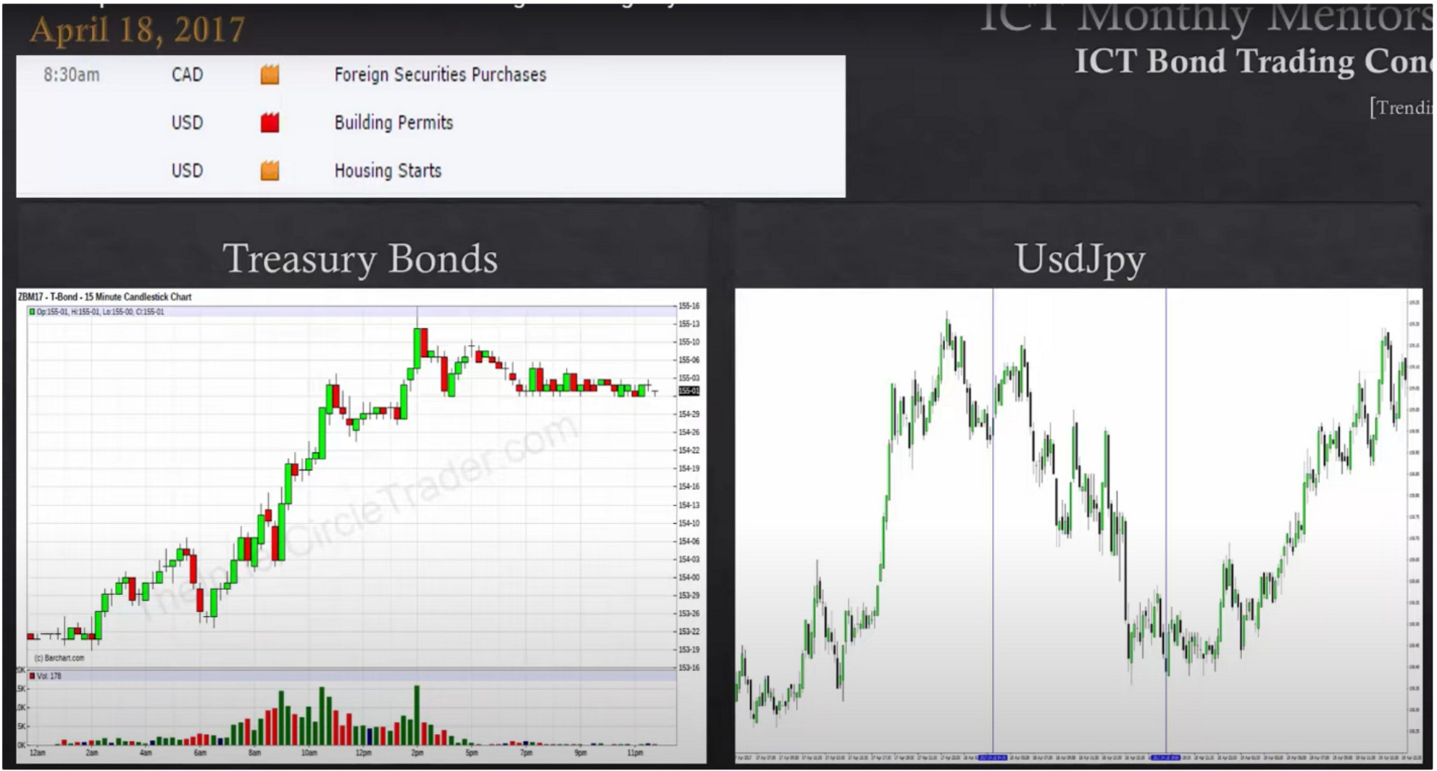

The divergence between the bond markets is a confirmation of the coming expansion

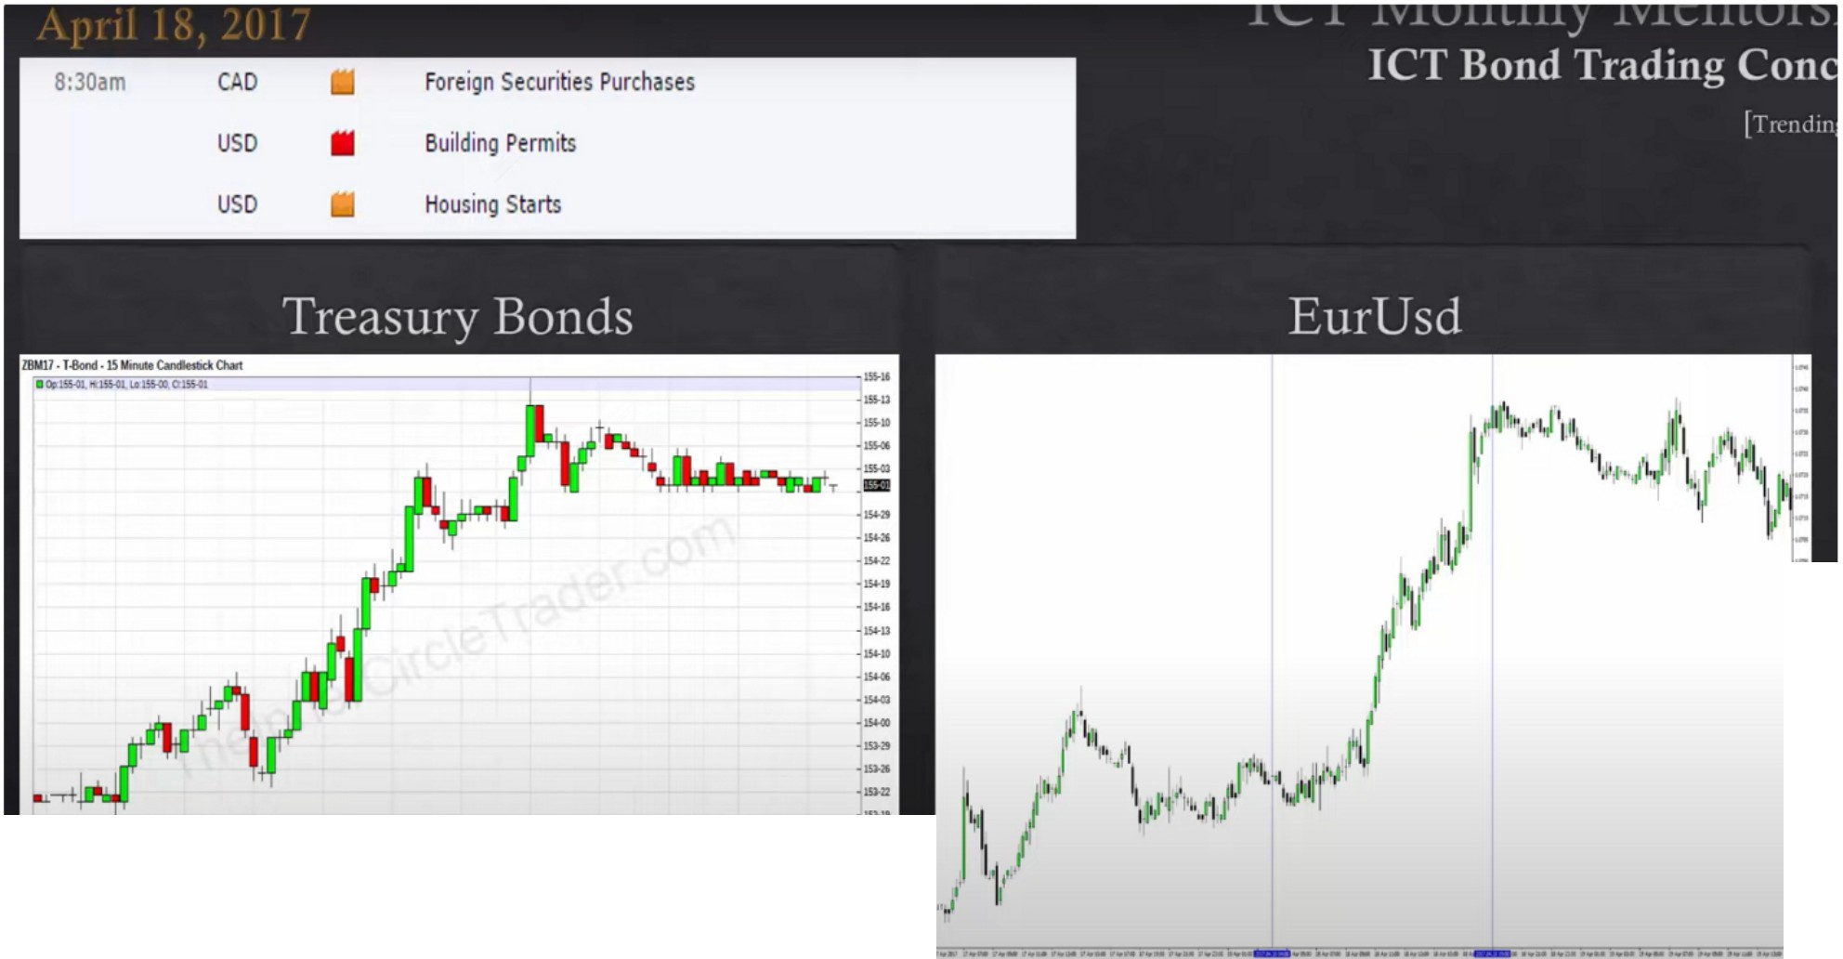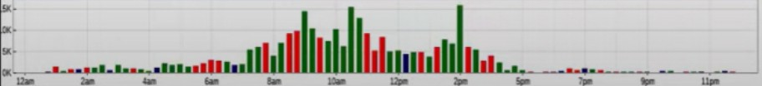

-■....111

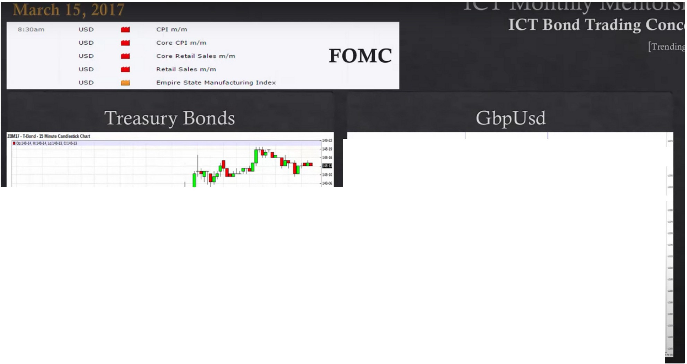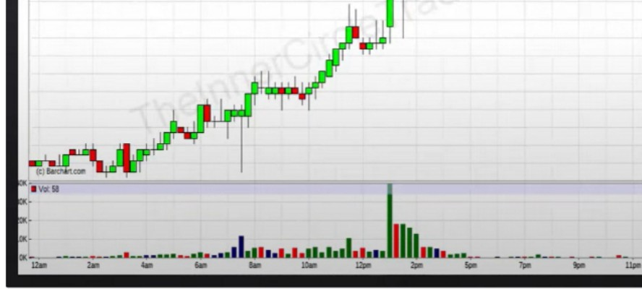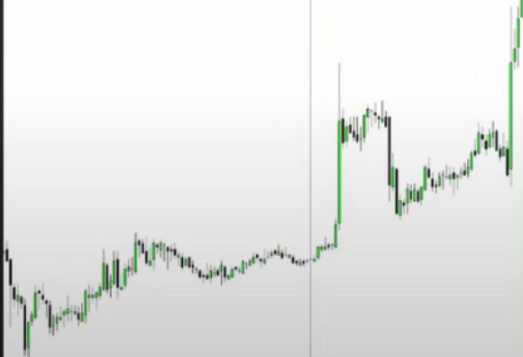

l1*1* 'f--

1,·...,,,

I 1

r

-

,·,,,w il1i11

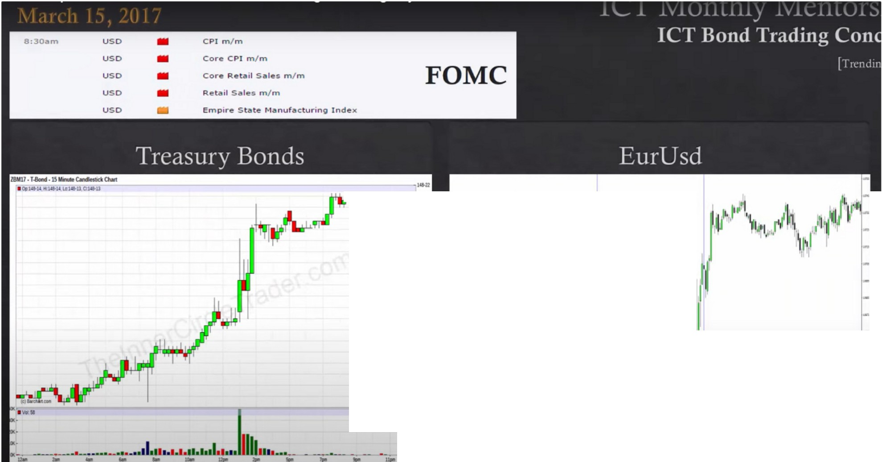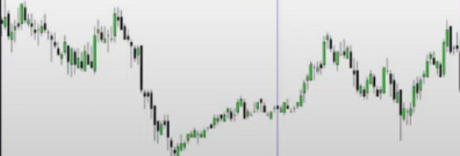

T :::

.-.­...

When trading indexes we're going to refer back to this as well, and for stocks as well Homework

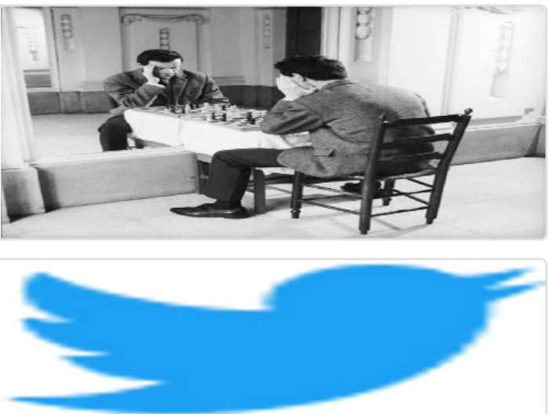Arjo I Twitter, lnstagram I Linktree

Linktree. Make your link do more.

1 https://t.co/HhmmTN1fUI

JavaScript is not available.

*"fl* https://twitter.com/arjoio